Curriculum Intent, Implementation and Impact – EXPERT MUSIC

“MUSIC education is the key to unlocking a child’s potential and creativity” – Herbie Hancock (Jazz musician)

Our Community:
Children at Keresley Newland are individuals and come from a range of social backgrounds, with a narrow knowledge of the wold of MUSIC beyond what they experience on social media. Vocabulary is typically limited, and children lack the vocabulary required to describe and respond to music, including their own. They enjoy school, and some are keen to share their achievements. The typical learner spends much of their time on technology, keeping up with their peers playing the latest games; and also spending free time playing outside with their friends, and therefore has limited experiences of composers, musicians, concerts and classical music. Children sometimes lack resilience as learners, and this applies to learning a musical instrument and as children often give up if their work does not meet their intention.

Curriculum Intent:
Keresley Newland aims for children to have a wide vocabulary to express their views on EXPERT MUSIC, musicians and compositions, and to read about composers and their works with interest. Children develop confidence to experiment and invent their own compositions, seeing themselves as EXPERT MUSICIANS. EXPERT MUSIC is taught within the context of a theme for learning where possible, to enable children to see links between knowledge; and build their own understanding of connected learning. This helps children to see learning as part of life. Children will be given every opportunity to develop their ability, nurture their talent and interests, express their ideas and thoughts about the world, as well as learning about MUSIC and Musicians across cultures and through history, expanding their horizons. Children will know that their contribution to MUSIC is important, and that MUSIC is personal to the individual. We aim for children to create, experience, and participate in the world of the arts and culture; and develop the knowledge, skills and language to immerse themselves in MUSIC in a way that is authentic and takes them on journeys beyond their life, experience and community.

Curriculum Implementation:
At Keresley Newland, EXPERT MUSIC is a positive, engaging and inclusive experience that enables every child to develop their musical potential, develop an appreciation of the value of music. The EXPERT MUSIC curriculum is taught through units which complement the story theme where possible. Enrichment activities form part of the EXPERT MUSIC. EXPERT MUSIC lessons develop key musical knowledge and skills, whilst supporting language, reading and vocabulary acquisition. Creativity and independent thinking are embedded into themes, supporting children in making their own creative choices and decisions, so that their MUSICAL outcomes, whilst still being knowledge-rich, are unique to the pupil and personal. Children to enjoy making music, and have a respect for the role that MUSIC plays in society. Children encounter inspirational and aspirational musical role models that reflect the world: past, present and future, in all its diversity. This supports children in having a deep understanding of who they are as a learner in the context of Music; and supports them in being part of the MUSIC world and brings MUSIC into their own community.
MUSIC is an important part of the Keresley Newland curriculum and is delivered by a specialist MUSIC teacher. We use the ‘KAPOW’ scheme of work alongside the Model MUSIC Curriculum which supports all of the requirements of the National Curriculum and gives children access to a wide range of musical concepts and experiences.

Intended Impact:
The EXPERT MUSIC curriculum is designed for children to gain a joy of MUSIC and understand its importance and how they can contribute to the world of Music. Children gain a rich vocabulary and breadth of knowledge, opening their minds to new worlds and horizons. Children are involved in evaluation, dialogue and decision making about the quality of their outcomes and the improvements they need to make. By taking part in our regular discussions and decision-making processes, children will not only know facts and key information about musicians and composition, but they will be able to talk confidently about their own learning journey, have higher metacognitive skills and have a growing understanding of how to improve, supporting them in their understanding of Language and themselves as a learner and an EXPERT MUSICIAN.

We intend to inspire musicians of the future and create a passion for MUSIC in all our children that will stay with them for a lifetime.

Our Expert Musicians:
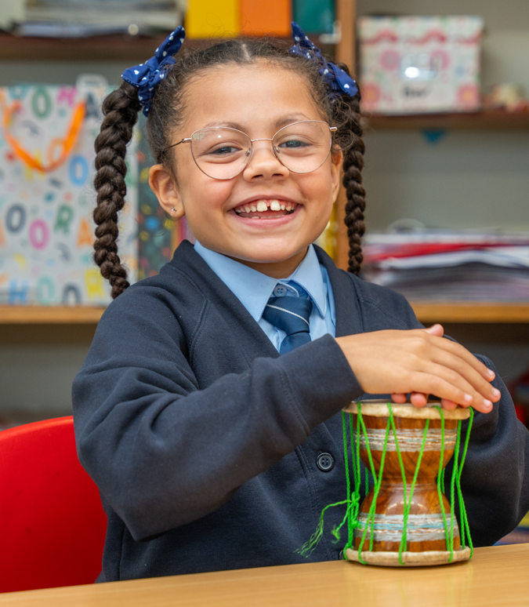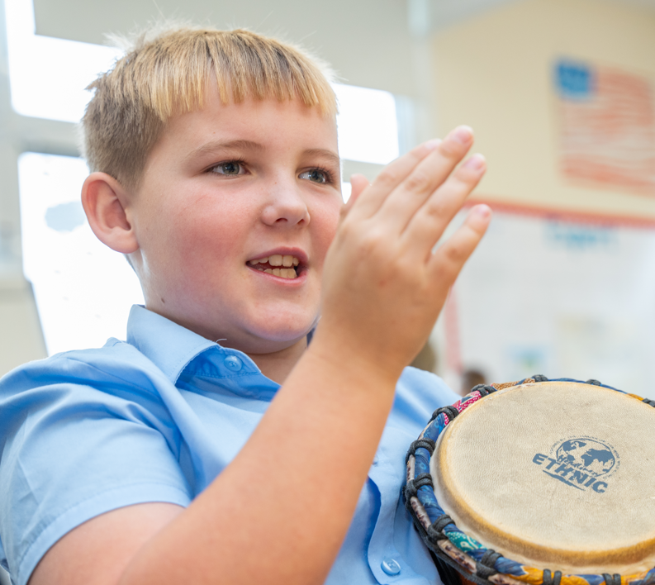
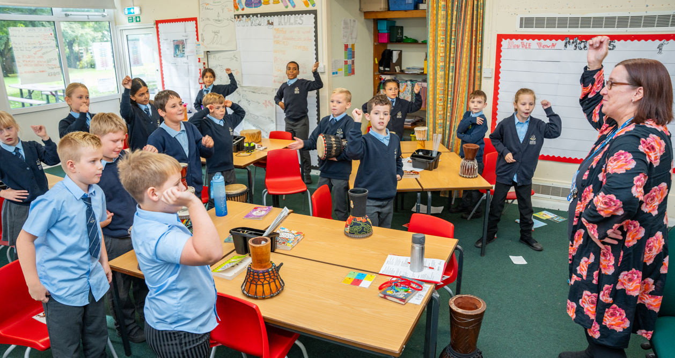
Photos of Y6 MUSIC Work:
Comments from Y6 leavers about being Expert Musicians

 | Keresley Curriculum Community to Impact
 | Language: | Learning: | Lives:
Community | Vocabulary is typically limited, and children lack the vocabulary required to describe and respond to music, including their own.  Children have a limited technical musical vocabulary, but can express their opinions and preferences. | Children sometimes lack resilience as learners, and this applies to learning a musical instrument and as children often give up if their work does not meet their intention. | Children at Keresley Newland are individuals and come from a range of social backgrounds, with a narrow knowledge of the wold of MUSIC beyond what they experience on social media.  They enjoy school, and some are keen to share their achievements.  The typical learner spends much of their time on technology, keeping up with their peers playing the latest games; and also spending free time playing outside with their friends, and therefore has limited experiences of composers, musicians, concerts and classical music.
Aims | We will support our children in understanding that MUSIC is a language that transcends words to express emotions, thoughts and feelings.  Children will learn that MUSIC tells stories, paints pictures and is an international communication.  Children will develop and accurately use a wide ranging subject specific vocabulary.  We will enable children to be able to talk about what they have performed, composed and listened to, with increasing confidence. | Children will understand MUSIC through listening, singing, playing, evaluating, analysing, and composing across a wide variety of historical periods, styles, traditions, and musical genres.  Children will gain the knowledge to become EXPERT musicians who are able to compose, share and perform. | Children will develop ambition in as Expert Musicians to involve themselves in music, in a variety of different high-quality events where they are an active observer or active participant.  Through EXPERT MUSIC, children will develop transferable skills such as teamwork, leadership, creative-thinking, problem-solving, decision making, performance and presentation. We will provide opportunities for children to understand the value and importance of MUSIC in the wider community and world. We will promote MUSIC in the wider community and for families. We will help children to see MUSIC as an authentic career pathway.  We will actively recognise the vital place MUSIC holds in culture and community as it promotes diversity and is used to express the human personal, emotional, social and cultural identity.
Strategies | A carefully sequenced MUSIC curriculum enabling children to sing, listen, play, compose, perform and evaluate; and use the vocabulary to articulate their thoughts and feelings.  Children will explore MUSIC from a range of times and cultures and articulate their thoughts and feelings in response to the piece, with insight and a wide vocabulary  Children will have an increasing knowledge of Expert MUSIC vocabulary, which they use accurately.  Children will build knowledge over time, and revisit key knowledge; with key identified knowledge and vocabulary retained from each unit of learning. | A well-planned curriculum, with a clear steer to demonstrating why learning is important.  Clear progression based on KAPOW, and built-in opportunities to recall previous learning.  Knowledge organisers provide a road-map of learning and  S-Plans bring cohesion to the story theme, and demonstrate where MUSIC fits in with this.  We will develop MUSIC to provide additional listening, performing and composing opportunities outside of KAPOW, deepening learning. | Leadership opportunities –Arts’ Leaders.  Musical instrument tuition is open to all children, and whole class tuition is delivered at KS2 (Ukuleles, Keyboards, Ocarinas). Inspirational show-case sessions will inspire children to learn an instrument, and other wider links will be maintained with organisations such as Warwickshire Music and Armonico Consort. We will develop MUSIC as part of careers education, to set the foundation for ambition.  We will provide high-quality wider opportunities such as live performances, violin group, choir and concert opportunities.
Impact | Communicate an appreciation and respect for a wide range of musical styles from around the world, and understand how music is influenced by the wider cultural, social and historical contexts in which it is developed  Understand the ways in which music can be written down to support performing and composing activities (using the language of notation)  Demonstrate and articulate an enthusiasm for music and be able to identify their own personal musical preferences. | Meet the end of key stage expectations outlined in the National Curriculum for Music. | Be confident performers, composers and listeners and will be able to express themselves musically at and beyond school.
THERE IS A HIGH COMMITMENT TO THE SCHOOL FROM CHILDREN, FAMILIES AND THE COMMUNITY

LEARNING

Expert Subject: Music
MUSIC is a universal language that embodies one of the highest forms of creativity. A high quality MUSIC education should engage and inspire pupils to develop a love of MUSIC and their talent as musicians, and so increase their self-confidence, creativity and sense of achievement. As pupils progress, they should develop a critical engagement with music, allowing them to compose, and to listen with discrimination to the best in the musical canon.
Purpose of Study: NATIONAL CURRICULUM
The national curriculum for MUSIC aims to ensure that all pupils:
- Perform, listen to, review and evaluate MUSIC across a range of historical periods, genres, styles and traditions, including the works of the great composers and musicians
- Learn to sing and to use their voices, to create and compose MUSIC on their own and with others, have the opportunity to learn a musical instrument, use technology appropriately and have the opportunity to progress to the next level of musical excellence
- Understand and explore how MUSIC is created, produced and communicated, including through the inter-related dimensions: pitch, duration, dynamics, tempo, timbre, texture, structure and appropriate musical notations
National Curriculum
EYFS | Being Imaginative and Expressive ELG  Children at the expected level of development will:  - Invent, adapt and recount narratives and stories with peers and their teacher;  - Sing a range of well-known nursery rhymes and songs;  - Perform songs, rhymes, poems and stories with others, and – when appropriate try to move in time with music.
KS1 | Pupils should be taught to:  - use their voices expressively and creatively by singing songs and speaking chants and rhymes  - play tuned and untuned instruments musically  - listen with concentration and understanding to a range of high-quality live and recorded MUSIC  - experiment with, create, select and combine sounds using the inter-related dimensions of music.
KS2 | Pupils should be taught to sing and play musically with increasing confidence and control.  They should develop an understanding of musical composition, organising and  manipulating ideas within musical structures and reproducing sounds from aural memory.  Pupils should be taught to:  - play and perform in solo and ensemble contexts, using their voices and playing musical instruments with increasing accuracy, fluency, control and expression  - improvise and compose MUSIC for a range of purposes using the inter-related dimensions of music  - listen with attention to detail and recall sounds with increasing aural memory  - use and understand staff and other musical notations  - appreciate and understand a wide range of high-quality live and recorded MUSIC drawn from different traditions and from great composers and musicians develop an understanding of the history of music.

MUSIC combines both Substantive and Disciplinary Knowledge, and a general definition of these is as follows:
Substantive knowledge is the specific, factual content for the subjects, which must be connected into a careful sequence. Disciplinary knowledge is best described as the action taken within a particular subject to gain knowledge i.e. how we gain substantive knowledge.

Substantive and disciplinary knowledge in MUSIC:
Substantive Knowledge Substantive Knowledge in Music is based on the developing knowledge of the interrelated dimensions of music.
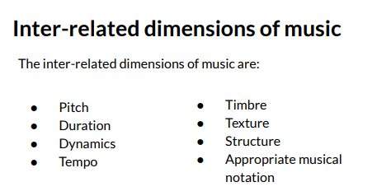

Substantive Knowledge focuses on developing the children’s skills and knowledge of the dimensions of music to enable them to develop as musicians.
Disciplinary Knowledge in music is how children use their knowledge of the dimensions of music when singing, playing instruments, improvising or composing.

The Music Curriculum:

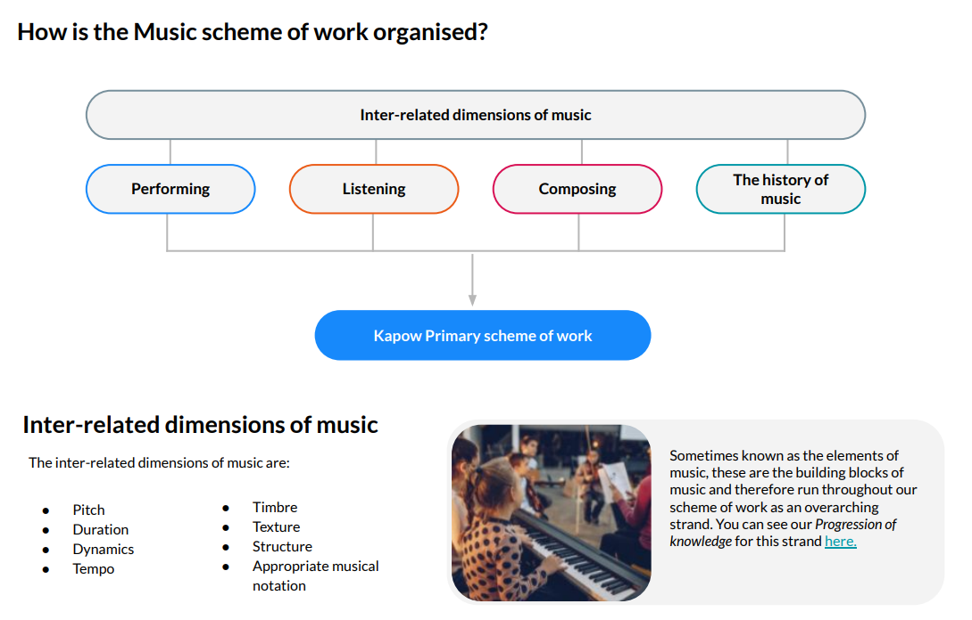

Assessment in Music:
Assessment in art is carried out through continuous assessment for learning through monitoring individual’s progress against the year expectations within a unit of learning.
There are clear descriptions plus examples of work at the expected standard and greater depth. Teachers assess against these descriptors for each theme for learning. The long-term memory is engaged through quizzes recalling key knowledge.

Impact: to be reviewed at the end of each year
2025:
Overview in place and curriculum written and mapped out, with most children being on track for age related expectations. LEARNING
4 key MUSIC experiences in place to enrich and provide aspirations. LIVES
Key vocabulary, reading extracts and high utility words used in MUSIC lessons. LANGUAGE
Children can articulate what MUSIC is. LEARNING
Quizzes demonstrate and increasing knowledge of MUSIC and MUSICIANS.

MUSIC DEVELOPMENT PLAN SUMMARY:

Overview
Detail | Information
Academic year that this summary covers | 2024 - 2025
Date this summary was published | September 2024
Date this summary will be reviewed | September 2025
Name of the school music lead | Gaynor Larkin
Name of school leadership team member with responsibility for music (if different) | Nicola Penlington
Name of local music hub | Warwickshire Music
Name of other music education organisation(s) (if partnership in place) | Armonico Consort, Coventry Music

“Music should be embedded in every primary school. Singing should be the golden thread through these years, with a clear commitment to quality teaching and opportunities for progression for all children from the start of their school education.” – The National Plan for Music Education (NPME)

Part A: Curriculum music
This is about what we teach in lesson time, how much time is spent teaching music and any music qualifications or awards that pupils can achieve.
Children are taught MUSIC for one hour per week by a MUSIC specialist.
The curriculum follows the KAPOW Scheme for learning and this is personalised to meet the needs of the children, afford performance opportunities and enable instrumental tuition.
The school is well-resourced for music and invests in specialist provision and instruments, including technology.
Singing is an important part of school life. Children sing regularly in music lessons.

Part B: Extra-curricular music
This is about opportunities for pupils to sing and play music, outside of lesson time, including choirs, ensembles and bands, and how pupils can make progress in music beyond the core curriculum.
Children also have an opportunity to learn an instrument with Manhattan Music. Instruments currently on offer are keyboard, guitar, ukulele, recorder and singing.
Our music teacher runs a weekly Violin group for 12 children (violins are on loan from Warwickshire Music).
Children have the opportunity to share their musical interests with their peers in EXPERT of the Week time.
We also seek to develop musical leadership for both staff and pupils by encouraging individuals to take turns leading sections of the school during rounds and partner songs in the weekly singing assemblies.

Part C: Musical experiences
This is about all the other musical events and opportunities that we organise, such as singing in assembly, concerts and shows, and trips to professional concerts.
Children take part in weekly singing assemblies, two concerts annually and other performance opportunities. Singing Assemblies for the whole school focus on developing good singing techniques, and incorporate a wide range of styles and genres, part songs, rounds, action songs, partner songs. They also give pupils an opportunity to lead singing from the front, and for children having instrumental lessons to perform to the school.
A number of music enrichment activities are provided for children each year. In recent years this has included opportunities to listen to live music (eg The Coventry Collective), to take part in high-quality school events (Concerts and school productions such as ‘Joseph and the Amazing Technicolour Dreamcoat’), and to participate in musical events outside of school (eg Planet Blue at Coventry Cathedral, the Big Sing at Warwick Arts Centre – organised by Coventry Music – and an African Music concert at Warwick Arts Centre – organised by professional music organisation Armonico Consort).
Live musical events occur termly in school, including mediaeval music and staff ensembles.

In the future
This is about what the school is planning for subsequent years.
Music as a career pathway.
Warwickshire partnerships, to widen offer within school.
School Choir – Christmas concert.
Practice opportunities for those learning instruments, within lunchtime space. Violin group pupils to be able to take their instruments home to practice.

Further information (optional)

