Learning Vision 2021

Rationale:
At Keresley Academies we believe that all children have the right to develop a superb understanding of language and wide vocabulary, within a love of stories; and develop a structure for life around the value of respect.
The two beliefs form our fundamental principles on which we have created our school.
Together children are: responsible; empathetic; problem-solvers; enterprising; collaborative; and successful, and this forms the basis for our value of respect.
We continually review our ethos and curriculum to ensure that we consider research and best practice to improve learning for our community.
Our School Improvement Plan, reflects this practice and our ambition for our school and the lives that we influence and shape.
This policy is based on our school aims of:

Aims:
- Language:
  - For children to develop a love of language and stories and use an extensive, rich vocabulary.
- Learning:
  - For our community to love learning, know who they are as learners and challenge themselves to extend and deepen this learning through becoming Leaders of Learning.
- Lives:
  - To be a community, supportive of each other, living by our value of respect.

and… The Futures Trust values of:
- Learners First – teachers and leaders totally focused upon the educational benefit of our students
- It’s About Learning – students, teachers and leaders focused upon developing and improving their learning and development
- No Barriers – no excuses, only support to ensure students, teachers and leaders maximise their achievements.

Our Community:
Children at Keresley Academies are individuals and come from a range of social backgrounds. They enjoy school, and some are keen to share their achievements. The typical learner at Keresley Academies spend much of their time on technology, keeping up with their peers playing the latest games. Although some children have access to more traditional and outdoor pastimes, many do not. This impacts on social skills, aspiration, general knowledge, vocabulary, spoken and written language and learning behaviours. Children at Keresley Academies lack resilience as learners, often giving up if learning is challenging.

Curriculum:
To meet the needs of our community of learners, the curriculum at Keresley Academies is based around providing language rich opportunities, with story and reading at its heart.
There is a focus on Growth Mindsets to promote resilience and the understanding that failure leads to new learning and is exciting.
For children to be successful in life and learning, we provide a rich curriculum covering a wide range of subjects, a breadth of knowledge and skills for life.

Intended Impact:
From this, children at Keresley Academies develop the skills to be successful in life with a breadth of knowledge and a wide range of skills that enables them to be Leaders of Learning. Children are articulate and thrive on extending their vocabulary, and read widely and with joy. Children become both independent and collaborative learners who love challenge and understand who they are as learners and as members of society. They develop a broad knowledge of different subjects and use this information to find out more. They are confident in themselves, but also show empathy and compassion to others. Children have high aspirations about their lives and their future. There is a high commitment to the school from children, families and the community.

Leaders of Learning:
Factors of Effective Learning is a document unique to Keresley Academies which sets the tone for learning. All members of the community strive to be Leaders of Learning and understand that this is a dynamic process that evolves as situations and roles within school change, and we take on new challenges.

The factors of effective learning are:
Accountability, Adaptability, Knowledge, Language for Learning, Passion, Relationships.
Our Factors of Effective Learning have Growth Mindset principles interwoven into their heart. There are two mindsets - Growth and Fixed. These mindsets form part of what we think about intelligence and ourselves as learners. If a person believes they cannot learn or that they must always get everything right – a fixed mindset, then this limits their ability to take risks, persevere and learn.

We expect children to challenge themselves and strive for improvement. This is a key part of learning and life. Developing a Growth Mindset is designed to help children realise they can grow their ability, and that learning is a life-long process.
Children track their journey of progress, in terms of Growth Mindset, with gold stickers to show how they have improved through determination.

Factors of Effective Learning:
 | Factor | Emerging | Developing | Secure | Leading
PROGRESS |  | Some progress is evident | Expected progress | Good progress | Excellent progress
Accountability | Challenge | Learners are exposed to challenge; may be resilient to failure. | Learners are exposed to challenge and use some support to overcome them (collaboration, resources). | Learners enjoy challenges of learning; are resilient to failure. Positive Growth Mindset. | Learners actively seek, set own challenge. Independently identify own mistakes and improvement.
Accountability | Expectations | Learners complete adequate amount of work. | Clear expectations outlined and reinforced constantly. | Leaders are determined that all learners will do well. | Learners take pride and have high expectations.
Accountability | Feedback | Learners given basic feedback and next steps – may be after learning | Feedback given in lessons; learners involved in next steps. | Peer- and self-assessment opportunities. Feedback given at point of learning. | Teacher, peer and self-assessment gives instant feedback to improve swiftly
Accountability | Application | Some application, not always independent. | Some application independently. | Application in different contexts independently. | Learners create own opportunities to apply.
Accountability | Data | Leaders have some understanding of next steps | Clear class and group next steps. | Leader knows data clearly within Bigger Picture; clear learning over time. | Children’s personal next steps carefully structured and have impact.
Adaptability | Environment | Range of seating.  Used to support learning. | Adapted for purpose. | Purposeful and creative.  Learners involved in it. | Fluid environment.
Adaptability | Responding | Needs of learners planned for | Lessons adapted to meet needs of learners | Leaders aware of barriers to learning; overcomes most | Leaders removes barriers to learning for all learners.
Adaptability | Activities | Learners are directed to activities/workshops.  Given strategies to use. | Learners choose activities/ workshops effectively.  Choose from given strategies | Creative choices challenge and deepen most learners.  Learners make links with other learning. | Choice and challenge well embedded to deepen.  Learners are enterprising.
Adaptability | Assessing | Ongoing assessment | Learners know how they are doing throughout lesson | Ongoing assessment used to challenge all learners | Learners actively involved in own assessment
Adaptability | Time | Pace appropriate throughout learning | Sufficient time given for independent/group work | Learners given quality time for exploration | Used flexibly to maximise learning.
Knowledge | Subject | Some missed opportunities. | Accurate. | Addresses misconceptions and deepen learning. | Knowledge of Bigger Picture used to deepen, challenge
Knowledge | Modelling | Some modelling | Accurate modelling. | Concise modelling. | Modelling deepens learning
Knowledge | Pedagogical | Pedagogy strategies used are sometimes effective. | Limited range of pedagogy strategies used effectively. | Range of pedagogy strategies used purposefully | Innovative use of pedagogy strategies
Knowledge | Planning | Awareness of desired outcomes but learning may be disjointed | Moves learning forward in a purposeful and engaging way | Innovative learning experiences using Kagan, Growth Mindset strategies | Personalised to meet individual needs.
Language for Learning | Vocabulary | Learners provided with relevant vocabulary | Learners prompted to use relevant vocabulary | Learners use vocabulary correctly to explain ideas | Learners apply vocabulary in different contexts
Language for Learning | Questioning | Limited range of questions, some open-ended. Limited impact | Leaders plan and ask range of questions. Learners may ask own questions | Leaders use questioning that causes learners to think deeply. Use spontaneous questions to challenge | Questioning leads to in-depth discussions between learners – Add, Build, Challenge
Language for Learning | Help | Learners ask teacher/ partner when stuck | Learners use previous knowledge and resources when stuck | Learners work in collaboration, use self-help strategies when stuck | Learners actively help when others need it - coaching
Language for Learning | Values | Leaders model RESPECT values | Leaders refer to RESPECT values | Learners encouraged to demo RESPECT values | RESPECT values integral to learning ethos
Passion | Enjoyment | Learners enjoy some of the lesson | Learners enjoy their learning | Learners enjoy challenge; resilient to failure | Learners extend learning for themselves beyond lesson
Passion | Thirst | Learners know they should join in with learning | Leaders are motivated and passionate | Learners are developing a thirst to know more | Leaders and learners use own thirst to let learning go in different ways
Passion | Purposefulness | Learners have little opportunity for independent or group work | Learners understand how to improve | Learners are accountable for their own learning | Learners display an independent drive to improve
Relationships | Behaviour | Mainly compliance. Problems dealt with swiftly. | Learners understand boundaries, work respectfully and follow school and class rules. | Learners feel safe and respected so behave well and engage in learning well. | Learners and leaders demonstrate a mutually strong rapport. Learners embrace their learning well.
Relationships | Collaboration | Learners are respectful of one-another | Learners work collaboratively with different peers | A range of collaborative working approaches are used (inc Kagan) | Learners support others when working collaboratively - coaching
Relationships | Support | Leaders work collaboratively with other adults in classroom, limited impact | Adults model positive behaviours and relationships | Adults work effectively together in classroom | Adults work flexibly together ensuring swift progress of learners
Relationships | Social | Learners are beginning to actively seek interaction with others to improve learning. | Learners are developing social norms (eg eye contact, appropriate manner) | Learners support each other | Learners work in a learning community, equipped to solve own problems together
 | Overall best fit | Emerging | Developing | Secure | Leading

Organisation of and Approach to Learning:
Keresley Academies have language, stories, reading and a love of books is at the heart of learning.

Most learning is centred around a story theme, and learning opportunities are planned around these themes. Some subjects remain ‘stand-alone’ and these tend to be Phonics, RE, Science, PE, Maths, Music and PSED. However, where possible, sensible and thoughtful links are made. However, all subjects are taught as disciplines in their own right.

Learning develops our core value of Respect, of which collaboration is part.
Kagan Co-operative learning forms part of lessons, as appropriate. http://www.t2tuk.co.uk

English:
English is at the very centre of learning at Keresley, as the ability to read with fluency and comprehension is a skill that underpins all areas of learning. This includes the acquisition of a wide vocabulary to support understanding. The following activities support language acquisition. Marking also supports this key skill and core school aim. The key principles that we follow to support the development of a wide vocabulary are to teach a wide vocabulary of every-day, subject specific and ‘high-utility’ words.
- introduce at least 5 words for each unit of learning
- tell the children the meaning of new words
- explore the words over the course of a theme through a range of short daily activities
- change the definitions of the words slightly throughout the theme to avoid rote learning
- move the word away from its initial context to ensure a deeper understanding
- encourage connections between words
- revisit previously learned words and use them in the classroom whenever possible
- praise and encourage interest in words
- teach high quality vocabulary and transferable words

Reading at Keresley Academies:
Reading is at the heart of the curriculum at Keresley. It forms a key part of all learning experiences with a focus on extending children's language. Children are provided with a wide range of reading opportunities, encouraging a love of reading that will stay with them throughout their lives. We want all children to form positive reading habits and become experienced readers before they move on to the next stage of their education.
Our aim is for all children to see themselves as readers; who are discerning about what they like; who are adventurous in their choice of reading material and who are motivated to read widely and constantly. Our practice in school is constantly evolving as we search for the way to ensure we give the greatest number of children the best chance possible of developing these habits.
Children are tested each term for Reading by a PIRA test and a STAR Reading test. The former supports teacher assessment and tracks children’s progress against national expectations and the later supports their wider reading with Accelerated Reader.

Phonics:
At Keresley Academies, we follow the Read Write Inc. phonics and spelling program.
Children begin their Phonics learning in Early Years where they are introduced to the phonemes (sounds) linked to the letters of the alphabet. Children use these to blend and segment simple words when reading and writing. Children then begin to learn the different phonemes, moving on to learning different ways of spelling each of the phonemes. Children use these phonemes to segment and blend more complex words, consolidating this by reading and writing simple sentences. At the end of Year 1 children will be tested on their phonics knowledge, using a national test featuring 20 real words and 20 pseudo words (nonsense). Our intention is to equip children who are 5 with the phonics knowledge and skills they need to be fluent readers by the age of 7.
Most children are ready to begin our Spelling program during Year 2. Read Write Inc. Spelling allows children to see connections between phonics, spelling patterns, rhyme and root words. This program moves progressively as children move through the school, building on previous knowledge. Each year group has a list of words and spelling patterns they are expected to be able to spell by the end of the year. You can find these on the Learning Resources for Home section of our website.
Children are taught phonics and spellings in short daily sessions, enabling children to build up the segmenting and blending skills they need to writing and reading. Each week children will have a spelling test, focusing on key phonics and spelling patterns they have practised during the week. You can support children by practising these at home. These words can be found in children red spelling book or using Spelling Shed.
Accelerated Reader:
At Keresley Grange you can almost feel the buzz about books. All children from Reception to Year 6 are actively involved in our Accelerated Reader programme, which hooks them in to reading and leads them on a quest for their next best read.

Accelerated Reader challenges our children and encourages them to extend their reading experience. Once they have read a book, the children take a quiz on it. A result of 85% or more in that quiz means the words are added to their word count. The children try to beat their monthly target, which takes them closer to their millionaire reader reward.
Accelerated Reader provides a structure for wider reading, based on comprehension and competition. This is a whole school concept that begins in Reception with a class reader, moving to a group reader. Children quickly become accelerated readers as they begin taking home books and quizzing. There are online quizzes for all school library books. When a child takes a quiz, if enough questions correct, then they gain points and collect words. Children in Fairytale Team aspire to gain 50,000 words with children in Adventure and Fantasy children are determined to be Millionaire Readers. Millionaire Readers are taken to the cinema.

There is a weekly word count and class leader board. There is a Boys v/s Girls competition most weeks and this continues to inspire boys in particular read.

The star reading assessment informs our children (and their teacher) of the number and colour of their reading level. Our librarians are available daily to support the children, as they choose their books from our busy school library.
Reading for pleasure is enhanced by sharing teacher’s own enjoyment, by reading stories from our book spine, which include a variety of classic and modern stories tailored to the different year groups.

These books are updated annually as new books are written and tastes change within school and year groups.

Year 5 and 6
Skellig, The Daydreamer, Clockwork, Holes, The Secret Garden, Wolf Brother
Year 3 and 4
The twits, The lion, the witch and the wardrobe, Charlotte’s Web, Gansta Granny, How to train your dragon, Harry Potter
Year 1 and 2
Year 2 Horrid Henry, Worst Witch, Flat Stanley, Owl who was afraid of the dark, Fantastic Mr Fox, George’s marvellous medicine
Year 1 Peace at least, Can’t you sleep little bear? Superworm
Reception
The Gruffalo, The Gruffalo’s child, What the lady bird heard, The three little wolves and the big bad
pig, Library Lion, Do monsters wear undies? Elmer, Something else, The incredible book eating
boy (9 books)

Writing:
Writing is taught in a structured way, starting with a story. The model that we are using is a personalised approach based around best practice taken from Talk for Writing, Storytelling and The Write Stuff. The school environment enfolds children in stories, settings and language. There is a focus on drama, oracy and language development as part of our approach to writing, and there are planned opportunities to inspire children to write and give meaning to the written and spoken word. Visual prompts support children in their writing journey.

The research of Jane Considine (The Write Stuff) is a development initiative in 2018, to enhance current provision and practice. The focus remains on a love of story, enrichment and language. Children are immersed in a key text, revealing plot points one at a time to maintain the excitement of revealing the story. This story forms the basis of the wider project and curriculum enrichment.

We add clarity to the mechanics of the teaching of writing. Children follow a method called ‘sentence stacking’. Sentence stacking refers to the fact that sentences are grouped together chronologically or organisationally to engage children with short, intensive moments of learning that they can apply immediately to their writing. Children learn to sentence stack, focusing on the style of the author and impact of words and sentences. The planning of these is based on the teacher’s assessment of the children’s learning needs.

An individual lesson is based on a sentence model, broken into three separate chunks:
- Initiate section – a stimulus to capture the children’s imagination and set up a sentence.
- Model section – the teacher close models a sentence that outlines clear writing features and techniques.
- Enable section – the children write their sentence following the model.

The Three Zones of Writing: The FANTASTICs (Ideas), The Grammaristics (Tools), and The Boomtastics (Techniques) support their learning, precision and writing.

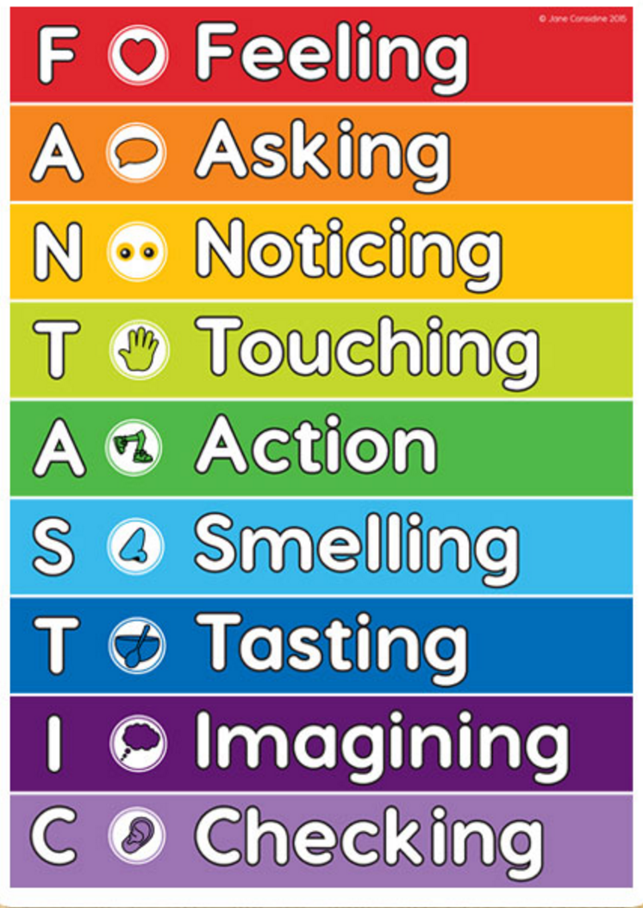

The FANTASTICs system allows children to identify the nine elements that all text types are comprised of. When pupils are familiar with these nine elements, they are able to ensure that they are incorporated into their writing.

The FANTASTICs help children to sharpen their understanding of their own and others’ writing by
encouraging them to be observant and reflective.

The BOOMTASTICs capture the ten powerful ways to add drama and poetic devices to writing. They help children structure their work, teaching them to showcase their writing voice, demonstrate originality and to take risks in a bid to capture the truth of a situation.

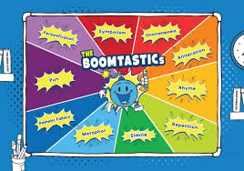

KS1:
- Onomatopoeia
- Alliteration
- Rhyme
- Repetition
- Simile

KS2: KS1 devices plus:
- Metaphor
- Pathetic Fallacy
- Pun
- Personification
- Symbolism

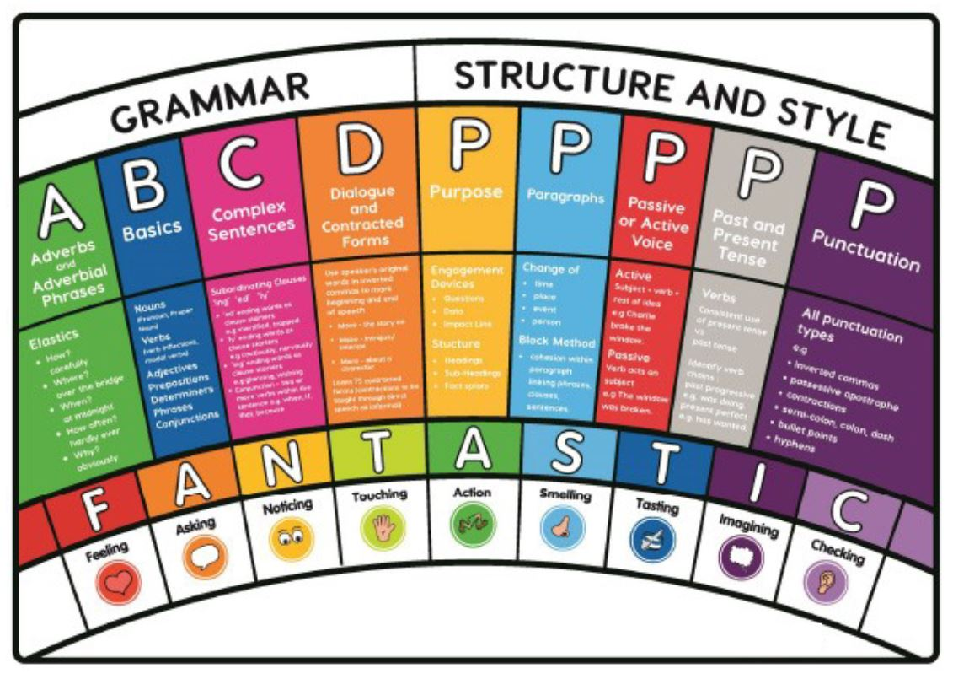

The GRAMMARISTICs cover national curriculum requirements, capturing the broad spectrum of key grammar knowledge.

Children at Keresley Academies are encouraged to see writing as a journey; re-drafting and editing are used before writing is published. Children use the left-hand side of their page as a place to generate and shape ideas.

Grammar is taught both discreetly and throughout the writing process.
There is a Routeway for the teaching of Grammar across the school.

Writing extends across the curriculum with the children being given opportunities to write for a range of different purposes outside of the writing lesson. This is through our Expert Curriculum.

Handwriting is taught discreetly using the RWI scheme in Fairytale Phase and then through a cursive script model when appropriate. This is practiced at least 3x weekly until children are able to join fluently. Children with additional needs have 1-1 support to aid fluency in writing.

All English based activities are extended with opportunities for Greater Depth, where children can take writing in their own directions. This includes project sessions, structure of English lessons, writing non-negotiables, assessment and marking.

Mathematics:
Fluency, reasoning and problem solving are at the centre of Maths learning. All Maths concepts are learnt through the use of concrete, pictorial and abstract approaches. Learners are given the opportunity to take control of their Maths learning through the structure of lessons.

Bronze, Silver, Gold and Platinum challenges are used to develop mathematical concepts and a Growth Mindset. These are flexible within each lesson, allowing rapid progress within and across lessons.

To enable children to become fluent mathematicians, daily opportunities are given to practice basic maths skills.

Times Table Rockstars, Fluent in Five and 99 Club are used to support this. All children are expected to use reasoning language throughout their daily lessons.

Children are tested each term for Maths by a PUMA test. The former supports teacher assessment and tracks children’s progress against national expectations and analyses gaps in learning to support the next term’s programme of learning.
There is a Maths Routeway followed through the school.


RE:
We follow the Coventry/Warwickshire Agreed Syllabus for RE. This is taught through discrete units of learning, and enhanced through wider curriculum opportunities such as the creative arts.

PSHE:
PSHE is taught weekly by class teachers. A core cyclical curriculum is planned and in place and designed to meet the needs of our school community. This is continually reviewed as the community dynamics evolve. The curriculum is based on PSHE Association documentation.

PE:
PE is taught through the REAL PE approach, based on core values.
Some aspects of PE will be taught on focus days and this will include Gymnastics and Dance.
Clubs continue to support competitive sport.

EXPERT:
New in 2019/20 is Expert Curriculum.
Children become experts across a range of subjects, and these form the basis of the wider curriculum. Expert lenses help children to be Scientists, Designers, Historians, Geographers and Artists during sessions each week. There is a focused approach to knowledge development and skills within this, and a strong focus on vocabulary acquisition and development. The wider curriculum is developed in this way, whilst providing enrichment opportunities for English and Maths as appropriate.
For children to make meaning within EXPERT, the Golden Threads of learning helps them make meaning in their learning through the concept of Lives. The Golden Thread links their life, to that of others; and there is a consideration on how life has developed and changed. Life is the Golden Thread that links all learning together - to the individual, personal ambition, key achievements and the wider world both now and through the ages.
Children are taught to reflect on the following questions to support the development of this knowledge of themselves, the world and others.
- How does this link back to _______________? (something learned previously)
- What does this remind you of?
- Where have we used some of this key vocabulary before?
- Where might this be relevant in your life?
- How might this be useful in the future? What about jobs?
- What is the point in learning it?
- Are there specific famous people, landmarks, events…..that add to meaning? (Cultural Capital)
The wider curriculum is also taught during Experience Days within The Write Stuff and as part of G2BG.

Homework:
Weekly homework is provided and failure to complete this results in detention as children become independent and responsible learners.
There is a written piece plus daily reading and spelling activities.
Online activities include TT Rockstars to develop Times Tables skills.

Other:
We are actively involved in a number of local and national projects to support learning and ensuring the best opportunities for children and families. These include STEM, Artsmark, Coventry Music, Growth Mindsets, Kagan, TFT Teaching School and The Write Stuff.

At Keresley Academies, we want the very best for our children and do all that we can to make sure all children have a strong foundation in their Language, their Learning and their Lives.

